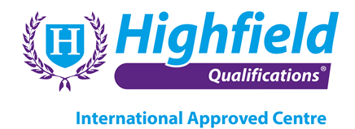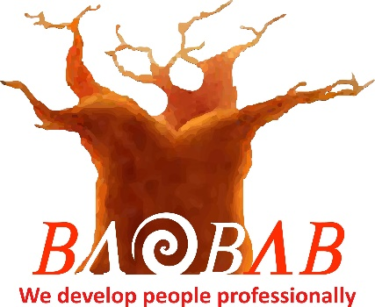

**FOOD SAFETY**

**Highfield Level 3 Award in Food Safety for Catering (RQF)**

The objective of this qualification is to support a role in the workplace and give learners personal growth and engagement in learning. The qualification is designed for learners who wish to progress to higher or supervisory level within a food catering business.

Learners achieving this qualification will be able to apply the knowledge relating food safety legislation, the application and monitoring of good hygiene practices, how to implement food safety management procedures and the application and monitoring of good practice regarding contamination, microbiology and temperature control within the food catering industries.

**Unit Standards**

**Unit 1 – Introduction to Food Safety**

**Unit 2 – Micobiological Hazards**

**Unit 3 – Contamination Hazards & Controls**

**Unit 4 – Food Poisoning**

**Unit 5 – Personal Hygiene**

**Unit 6 – Premises & Equipment**

**Unit 7 – Cleaning & Disinfection**

**Unit 8 – Pest Management**

**Unit 9 – HACCP**

**Unit 10 – Food Safety Legislation**

**Pre-requisite Qualification**

**Highfield Level 2 Food Safety in Catering (RQF) or suitable equivalent**

**Assessment Methods**

This qualification is assessed through a 90 minute, 45 question multiple-choice examination. Learners must achieve 66% in order to pass.

**How long will it take me to achieve this qualification?**

The total qualification time for this qualification is 3-4 days of guided learning. This course is only available in an online format. Technical requirements apply in order to complete this course and remotely invigilated examination.

**Where can this course be taken?**

Baobab Development Solutions – Cape Town – South Africa

Qualification Number: 603/4942/6 Credit Value: 3